LAB 4

1- Write a program that simulates rolling a dice (randomly generates a number) and prints Persian number name.

yek (1), dü (2), se (3), cehar (4), penc (5), şeş (6)
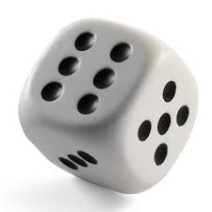
Note: Use switch-case structure.

Examples:
(assume that program generated 4 randomly.)
Output: cehar

(assume that program generated 6 randomly.)
Output: şeş

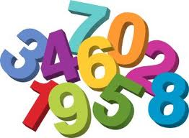
2- Write a loop that prints the following output on the screen.

4 10 16 22 28 34 40 46 52 58 64 70 76 82 88 94

Note: Use for loop

3- Write a program that takes lower and upper limits from the user and then calculates the sum of all the integers from the lower limit to the upper limit.

Example:
Inputs: 5 9
Output: 35 (i.e. 5 + 6 + 7 + 8 + 9)

Example:
Inputs: 5 5
Output: 5

4- Write a program that prints the following output:

1/64 0.016
2/64 0.031
3/64 0.047
4/64 0.063
5/64 0.078
3/32 0.094
7/64 0.109
8/64 0.125
9/64 0.141
10/64 0.156
11/64 0.172
12/64 0.188
13/64 0.203
14/64 0.219

5- Write a program that takes 8 integers from the user and prints odd integers.

Example :
Input: 21 18 12 15 37 32 28 6
Output: 21 15 37

6- Write a program that takes 6 binary numbers from the user and prints out how many times one (1) is repeated.

Example:
0 1 1 0 0 1
Output: 3 times

7- Write a program that prints the following time information.

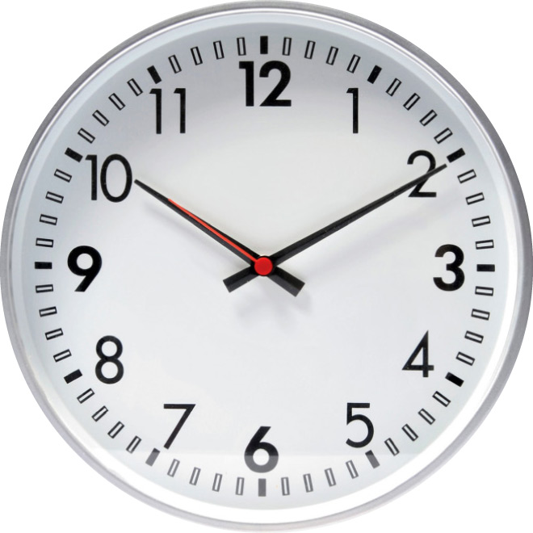
12 midnight
1am
2am
...
12 noon
1pm
...
11pm


8- Write a program that multiplies two numbers using plus operator.

Example :
Input: 6 4
Output: 24

9- Write a loop that prints the following output on the screen.

4 10 16 22 28 34 40 46 52 58 64 70 76 82 88 94

Note: Use while loop

10- Write a program that takes an integer N from the user and finds the sum of the following series till N terms.

1 + 3² / 3³ + 5² / 5³ + 7² / 7³ + ...

11- Write a program that rolls a dice and prints “how many times the dice rolled before it comes up 6.

The program should show the results of all rolls.

Note: Use “do while” loop

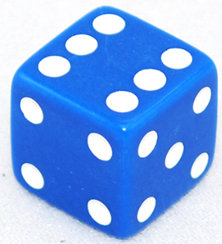
Example:
Output:
1. try 3
2. try 4
3. try 1
4. try 1
5. try 5
6. try 2
7. try 6

It came up after 7 tries.

